BIG DATA PROCESSING
TWITTER ANALYSIS

PART – A
TWEET LENGTH ANALYSIS

The program consists of 1 Map/Reduce job.
The code for the Mapper which calculates the tweets of length less than or equal to 140 is:

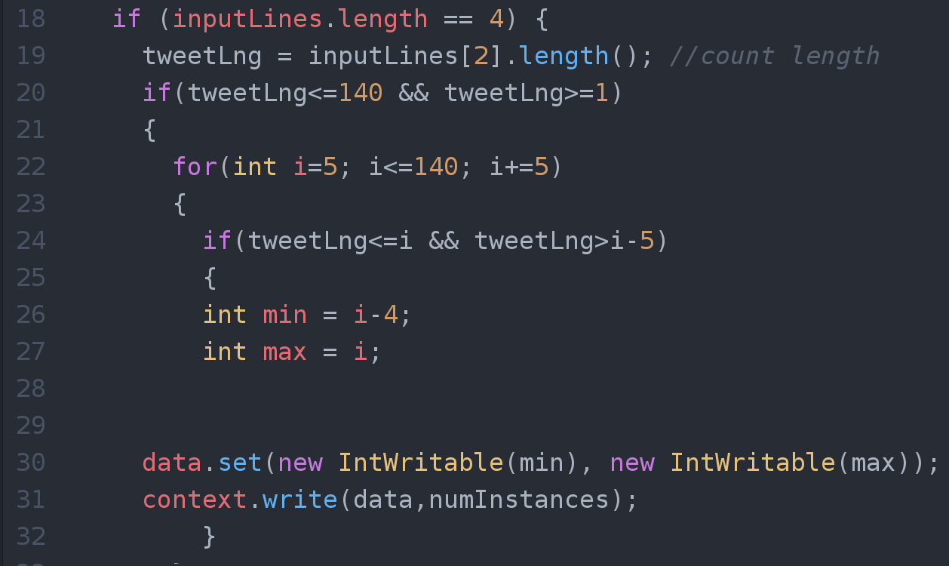

- inputLines in an array which takes in the input from the data set that has been splitted at the “;”
- The tweet text is stored at the second index of the array inputLines[]
- If the length of the tweet text is between 1 and 140, we enter a loop and by using a control variable i, we create bins for the histogram named min and max.
- data is of type IntIntPair and it is set to two new IntWritable instances.
- This data is sent to the reducer which processes it and provides the output in the form of a text file.
Using the text file we create a histogram.
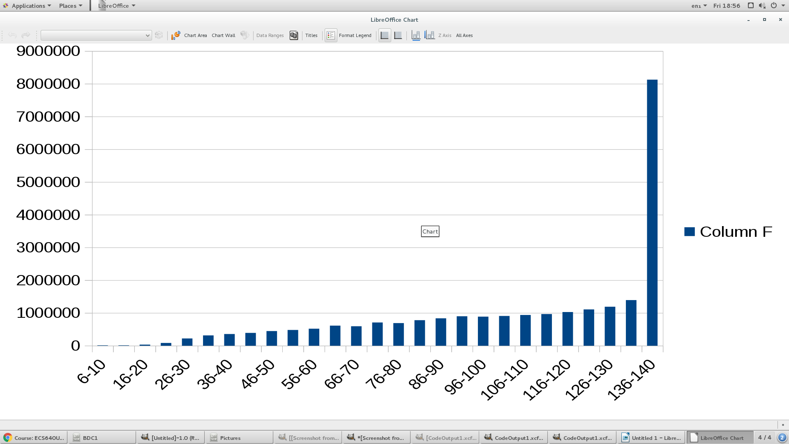
The output shows the lengths of the tweet:

PART – B
TWEET HOUR ANALYSIS Part 1:

The mapper code which converts the given input in milliseconds into hours:
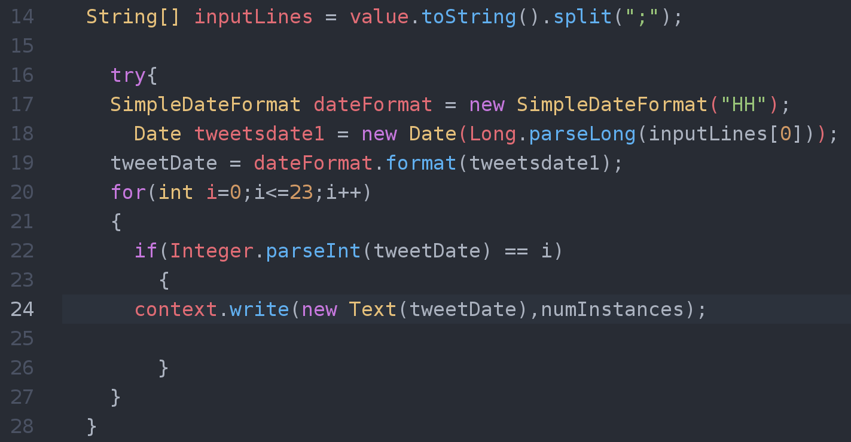

- The inputLines[] is an array which accepts the input from the dataset and splits it at “;” and stores the values obtained at indices starting at 0.
- We create an object (dateFormat) of the class SimpleDateFormat which accepts the parameter “HH”
- tweetsdate1 is a parameter of the class Date which converts the value stored at inputLines[0].
- format() is a function of the class SimpleDateFormat which is accessed by the object dateFormat and takes a parameter tweetsDate1 and sets it to tweetsDate.
- Convert the value of tweetsDate to an integer and check its value with a control variable i, in the range 1 to 23;
- The value of tweetsDate is then converted to text and sent to the reducer.
- The reducer accepts the text tweetsDate performs the reduction and the output is obtained in the form of a text file.

The final output obtained after running the Map Reduce job is:
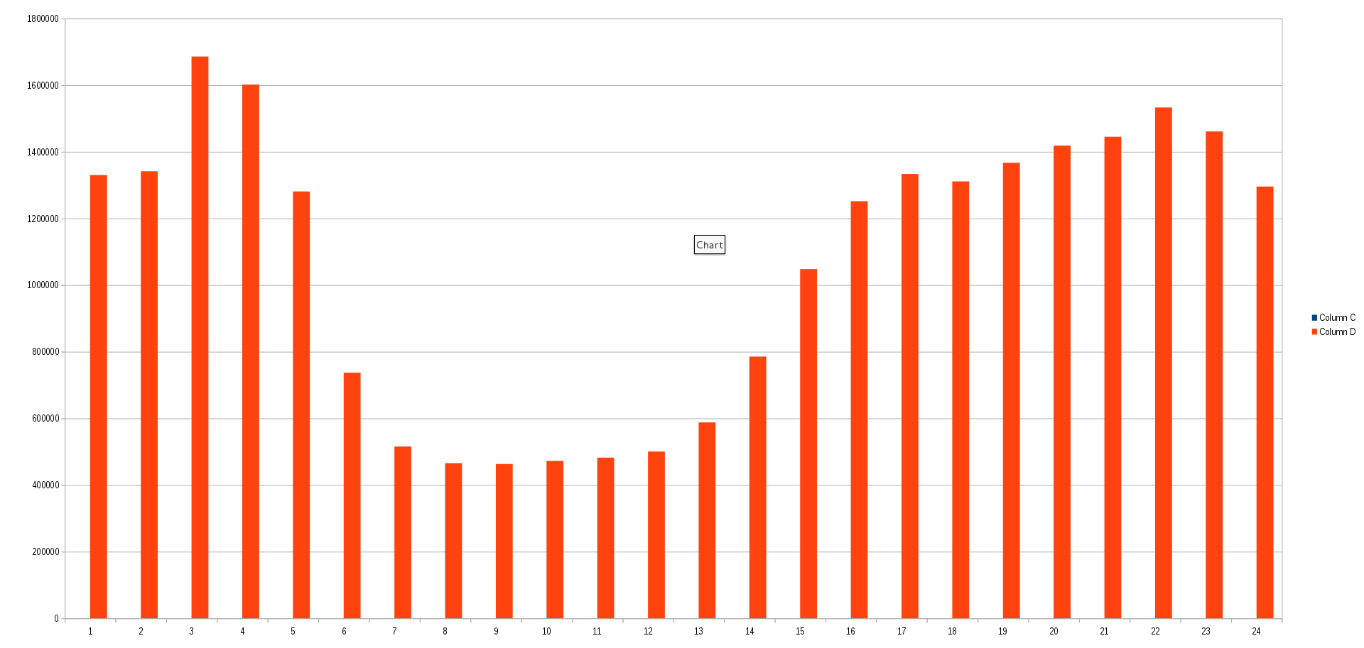

PART – B
TWEET HOUR ANALYSIS Part 2:

The code snippet of the Mapper for HashTag analysis which calculates the hash tags most used :
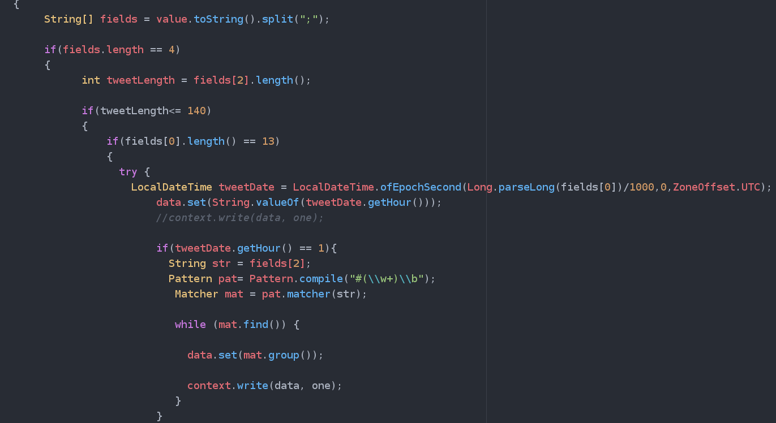

- The fields[] array takes in the input from the dataset and splits the data at “;”
- tweetLength is an integer the holds the value stored at field[2], which is tweet text, the length of this tweet text is calculated by using the length() function.
- For all the tweets of length greater than 140, check if the time of the tweet is a 13 digit integer, for all these values we perform the computation.
- tweetDate is an object created which belongs to the class LocalDateTime .
- The fields[0] which is the epoch time is converted to a long, and the ZoneOffSet object of the class ZoneOffSet is passed as one of the parameters converts the tweets time to the relative time zone.
- The output of the getHour() function at the tweets date is converted into a string and set to data.
- An object of the class Pattern is created and is check to find a pattern in the input data, an object of the class Matcher checks if there is a match.
- If there is a successful match, the value of data is set again and is sent to the reducer.

The output of the HashTag analysis Displaying the top 10 hash tags is:
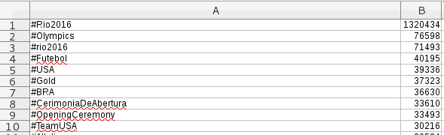

PART – C
HASH TAG SUPPORT ANALYSIS:

The code analysis the support an athlete received during the entire event. The support is measured in terms of the number of times the athlete's name was mentioned in a hash tag.

The output after successful Map Reduce for the /data/olympictweets dataset proves us with an output text file consisting a list of Athlete names.

- In getting the atheletes names from the dataset we use the HashSet<String> class. We process this Hashset string object using a string.
- We access all the names of the athletes and store it in a variable.
- This variable is then provided as the input to the reducer.

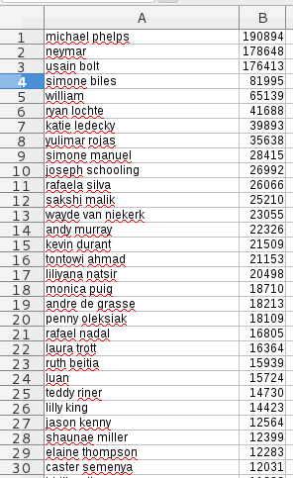

The output of the previous Map/Reduce job is taken in as input of this job. The joined dataset is accessed in this Map/Reduce job.

